ANALYSING HOUSE PRICES IN METROPOLITAN AREAS OF INDIA

Project Name:

Analysing House Prices in Metropolitan Areas of India.

Submitted By;

1. Naveen Raj

M. Kalai Kumar

M. Mohammad Hameem

S.H. Sheik Muhammad Ismail

**Introduction:**

Since the inception of the theory and idea of development, the common feature that emerged in different point of time is the developmental gap that emerged in different parts of the world and also among various part of a country in a particular time period.

Empathy map:

First we collect the project information about my team mates. And the data are things, feels, says, does. We done the Empathy may.

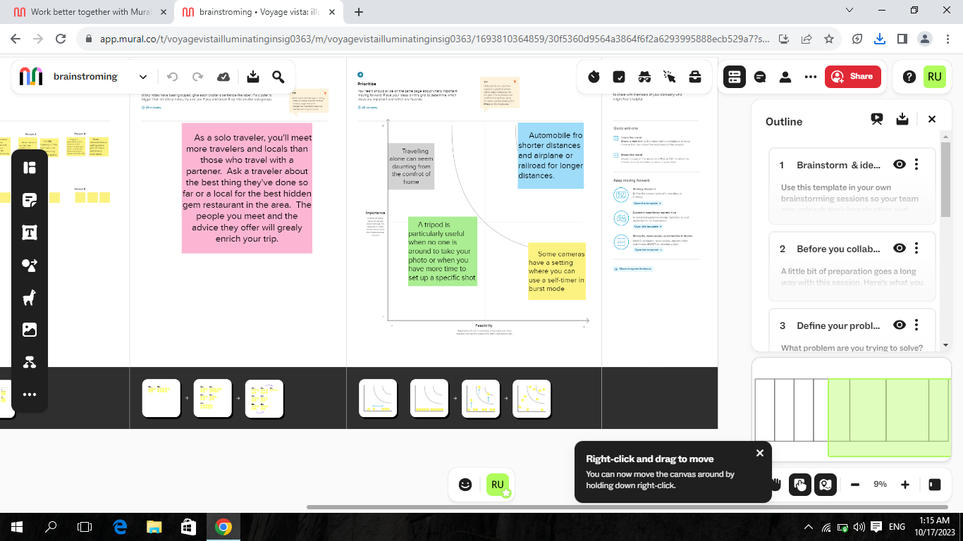

Brainstroming:

And then we make the brainstroming in mural website. And upload the project is gitup.com.

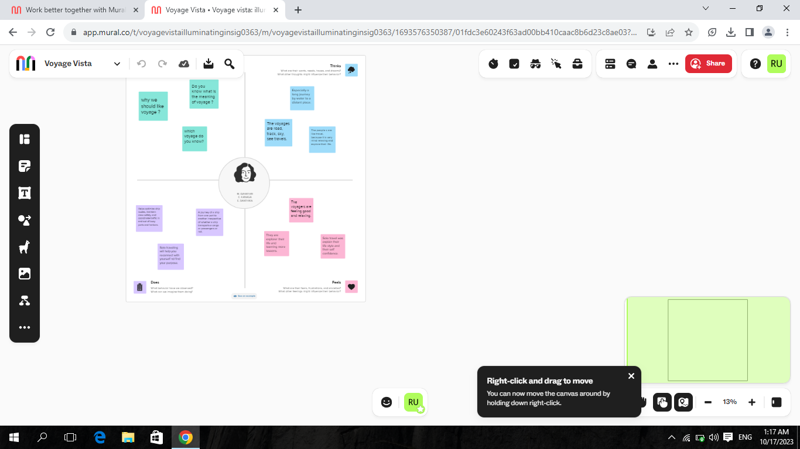

Tableau:

Use Tableau Public Software to create the nine excel sheets, let see my team project.

House prices in metropolitan of India. Then we create the four dashboard and last we make the story.

Dashboard -1